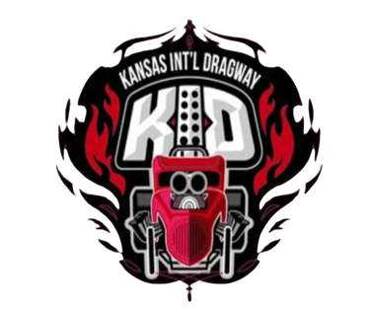 | KANSAS INTERNATIONAL DRAGWAY  2025 HEADS UP CLASS RULES  All classes 1/8 mile

Index Class
- Deep staging allowed
- NO dragsters
- NO throttle stops
- NO delay boxes
- Buybacks 1st round only
- 6.50 & 7.50 - .500 pro tree; 5.30 & 5.80 - .400 pro tree
- 2 qualifiers
- ladder starts 3rd round based on closest to the index in 2nd round

Big Tire
- Door cars, funny cars, altered, and pro mods
- NO dragsters
- Open tire size
- .400 pro tree
- One test run

Small Tire
- NO dragsters
- 28 x 10.5 Non W
- 275 Max
- Engine Diaper required
- .400 pro tree
- One test run
- laddered pairs

